The Church of St. Andrew, Barnwell
commonly known as “The Abbey Church” Cambridge

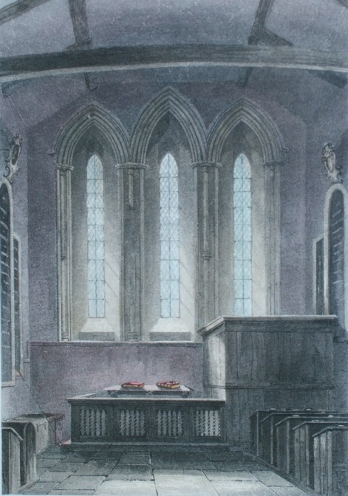

The History

This little Church of St. Andrew was once overshadowed by a large and magnificent Church which stood some distance behind it, nearer the river. It was one of the finest and largest in the whole country the Church of Barnwell Priory.

The first mention of the present “Abbey” Church occurs in Pope Nicholas’s Taxation in 1291. . There it is called Capella de Bernewell, and the Prior of Barnwell is stated to be its Rector. It seems very probable that this Church was built by the Canons of the Priory for the use of the inhabitants of the hamlet of Barnewell. It replaced an earlier cell dedicated to St Andrew which had once been occupied by ‘Godeson’ the hermit. It is practically all that remains of the great religious establishment here. Only one small portion of the Priory itself is now left in the area, the Cellarer’s Chequer, at the corner of Beche Road and Priory Road. The roof structure of the Priory Church nave it thought to be at Willingham and the Chapter House roof structure at Rampton Church.

When the great Priory Church was gone, our little Church stood alone.

The name “Abbey” Church may be doubly mistaken; it was attached to a Priory, not an Abbey; and this Church was not a Priory Church at all, but provided by the Priory for the villagers. But it is a convenient name, and its origin can be well understood. This Church and six of the fifty houses in the hamlet alone escaped destruction by fire on the 30th September, 1731.

Small as it is, it is the mother Church of a once huge parish. The area now contains about half the population of Cambridge. In 1825 the little Church of St. Andrew the Less, commonly known as The Abbey Church, appears to have been allowed to fall into decay. This coupled with the swift increase of the population in the area led to a temporary wooden church being built in 1826 by the then Lord of the Manor, Perpetual Curate (Incumbent) and Patron Revd. Dr James Geldart. This stood on the ground now occupied by Mill Road Cemetery Lodge and was known as Barnwell New Church (demolished 1839). Christ Church was built in 1839 and was soon used as the Parish Church and its position was regularised by legal instrument in the 26th January 1846. St Andrew’s Church was close for public worship at this time. In 1854 its restoration was undertaken by the Cambridge Architectural Society and re-opened on Easter Sunday 1856. The work was carried out by Rattee & Kett under the direction of Richard Reynolds Rowe a local architect.

The Architecture

It seems that the Church was built in the early thirteenth century, for its style is uniformly early English; some windows have been inserted at a later date. It is without aisles or division of nave and chancel.

The east window is one of the most beautiful specimens of the kind in the neighbourhood of Cambridge. It is an early English triplet which is quite plain on the outside, but the interior is decorated with long slender shafts of Purbeck marble supporting the simple deeply-cut mouldings of each arch, and neatly finished with small circular bands and capitals.

The 2 lancets at the west end, and other windows of the style in the Church, are without these ornaments. Near the pulpit is a fourteenth-century two-light low side window which is transomed. None of the stained glass is old, but the clear window in the north wall of the nave contains medieval crown-glass. There are traces of early thirteenth-century colouring on the walls under the lime wash.

In the north wall is a stairway that led to the old rood-loft. An elegant and light rood-screen richly carved coloured and gilt, which was in place in 1845 but was probably removed in the restoration. So has an iron hour-glass stand which was near the pulpit in 1811.

There are 2 good doorways; the north door communicated with the Priory, it has a pointed arch traversed by a slender canopy. The south porch, built in 1929, replaced an earlier one and in the 1950’s a choir vestry was built outside the north door.

Other points of interest

There is a double piscina and an ancient coffin lid on either side of the chancel. The modern Communion table took the place of a Jacobean table which stands at the back of the Church. All the Communion plate seems to be Victorian as one of the patens is dated 1887. The Organ which dates from the 1856 restoration has an unusual embossed centre pipe in the case. The first recorded marriage here, in the Bishop’s transcripts of the registers, is that of “Rychard Read and Martha Lapis 14th June 1599.

Against the west wall of the churchyard are six mural tablets, once in the chancel, erected by a squire, Jacob Butler. The inscriptions tell of his ancestors and himself.

After Christ Church was built new parishes were constituted as further Churches were built.

St Paul’s, St Matthew’s, St Barnabas and St Philips, as well as St John’s Church in Wellington Street which was licensed for use as a Children’s and Mission Church in 1873.

In the 1930’s a hall was built in Coldhams Lane, called St Radegund’s to meet the spiritual needs of a large and increasingly populated area of the parish. A new Church was added in 1962 and called St Stephen’s.
This area of the parish was merged into St Philips in the early 1980’s. The Hippodrome in Auckland Road and the New Theatre on Newmarket Road were used for missions and much work was carried on at the Midsummer Fair over the years.

This House of God your Father
Opens wide her doors, and in
His Name bids you welcome
The Lord bless you and give you peace

