Christ Church
Cambridge

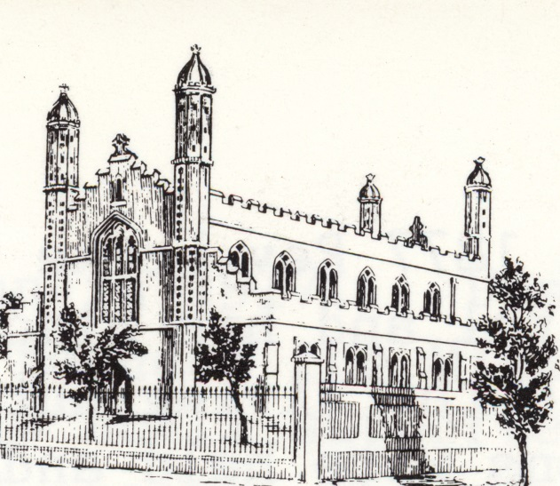

In 1825 the little Church of St. Andrew the Less, commonly known as The Abbey Church, appears to have been allowed to fall into decay. This coupled with the swift increase of the population in the area led to a temporary wooden church being built in 1826 by the then Lord of the Manor, Perpetual Curate (Incumbent) and Patron Revd. Dr James Geldart. This stood on the ground now occupied by Mill Road Cemetery Lodge and was known as Barnwell New Church.

In 1835 Dr Geldart parted with the Patronage to the Rev. Chas Perry, who, whilst never becoming the Incumbent threw himself heartily into Evangelistic work in the Parish.

The Rev. Perry was instrumental in the raising of the funds which built Christ Church which cost £3,800 of which he gave £200. He also planted the Parish of St Pauls again giving £200 towards the building of the Church. He became the 1st Incumbent of the new Parish and was appointed Bishop of Melbourne Australia in 1847.

From the Cambridge Chronicle of 25th May 1839 we read,

‘The handsome new Church lately built in the parish of St. Andrew the Less was opened yesterday, on which occasion two sermons were preached by the Revd. John Brown LL.B of Cheltenham. In spite of the unfavourable weather, the congregation were highly respectable, and the collection in the morning amounted to £41.13s and that in the evening to £22.8s.11½d.’

On the 27th June that year the Bishop of Ely, Dr. Allen consecrated the building and Churchyard.

Soon after the church was opened Barnwell New Church was demolished.

The “new” church is 28ft wide by 86ft long with aisles of 13.1/2 ft. wide and a lofty 44ft high and has been variously described as ‘of very peculiar outline and appearance’ and ’reminiscent of Kings College Chapel’. It has the rare distinction of being orientated North and South. This was once a bone of contention, for the glare of the so called east window during the summer was extremely disagreeable, which would account for the fitting of the stained glass in 1885. It may have been that the porch was added and the parish vestry enlarged at this time.

It is interesting to note that the font cover was given by the Sunday school children collecting pennies.

Christ Church was soon used as the Parish Church and its position was regularised by legal instrument in the 26th January 1846. St Andrew’s Church was close for public worship at this time. In 1854 its restoration was undertaken by the Cambridge Architectural Society and re-opened on Easter Sunday 1856.

After Christ Church was built new parishes were constituted as further Churches were built.

St Paul’s, St Matthew’s, St Barnabas and St Philips, as well as St John’s Church in Wellington Street which was licensed for use as a Children’s and Mission Church in 1873. At that time Wellington Street was one of the worst in the area. In fact many parts of the parish were at one time or other in a very low state of demoralisation.

When the church was built there were box pews filling the whole of the floor area. These were replaced in the 1880’s with pine seating which was reordered at various times. In 1913 major alterations and decoration was carried out and it may have been at this point that the girls and boys choir vestry’s were created.

In 1901 the disused premises of the old British School were purchased and converted into the Parish Hall or ‘Institute’ as it was known to everyone.

In 1937 the Jesus Lane Sunday School Trust build St Radegund’s Hall on the corner of Coldhams Lane and Brooks Road for Sunday School work in this expanding area of the parish. It was loaned to the Vicar for other spiritual and church work. In the early 1940’s the interior was altered to give a more church like appearance using the pulpit, communion rails and font from St John’s Church Wellington Street and the building dedicated as the Church of St. Stephen. In 1960 a new church was built next door and the previous building becoming the church hall. In 1982 this part of the parish was transferred to the parish of St Philip’s.

In the last half of the 1960’s there was talk of the redevelopment of the Kite Area (Grafton Centre) and the possible sale of the Institute arose and consideration was given to major alterations to the church. It was not until 1973 that the institute was sold along with Abbey Church Hall in Occupation Road, and work started, putting a floor at the gallery level with hall, committee rooms, kitchen and toilets on the ground floor and a still large worship area upstairs. The work took nine months and cost almost £40,000.

In 2002 exploration work started on a possible Church Graft in conjunction with St Andrew the Great (STAG). This would mean that on the retirement of the Rev Michael Diamond, the next vicar would bring with him around 100 people plus children along with some financial help for additional staff.
During the next two years a group led by the Rev Stephen Midgley began meeting separately from STAG for services and on the 18th July 2004 the two congregations worshiped together for the first time. The following Friday saw the licensing of the Rev Midgley as Priest-in-Charge and five years later as Incumbent.

The need to make changes to the building soon became clear and a crèche area was created in the hall. Plans were drawn up for additional toilets, new up-to-date kitchen, meeting rooms and offices, new heating system and redecoration. This work was carried out over several years without any major upheaval in the work of the church. The final phase, the replacement of the poor Victorian porch started in September 2012 and was reopened over the weekend of October 4-7th 2013.

Some of this information has been extracted from the books ‘A Jubilee Memorial’ by William White and ‘The Church in Barnwell’ by Arthur Peck and Sterndale Burrows. Also from the St Philip’s website concerning St Stephen’s.

